
THE POSTS AND TELECOMMUNICATIONS INSTITUTE OF TECHNOLOGY
DEPARTMENT OF INFORMATION TECHNOLOGY 1

DEPARTMENT OF INFORMATION TECHNOLOGY 1

MODULE: CUSTOMER PAYING
REPORT: REVISING+DESIGN

INTRODUCTION TO SOFTWARE ENGINEERING

Class | : | E22CQCN03-B
Course group | : | Group 6
Group topic | : | Mini football field management
Project group | : | Group 12
Group members | : | trần minh hiếu – B22DCCN320  Nguyễn Việt Hoàng – B22DCVT214  nguyễn tuấn minh – B22DCKH077  bùi minh tùng – B22DCDT293

Hà Nội - 2025

Concept Exploration
Concepts and Explanations
# | Concept | Vietnamese | Explanation
 | Human-related concept
1 | Field facility owner/proprietor (yard manager) | Chủ sở hữu cơ sở/Quản lý sân (Quản lý sân) | The primary owner or manager of the football field who oversees all business operations, ensures profitability, and manages key decisions.
2 | Operations manager | Quản lý vận hành | Manages daily activities, schedules, and ensures smooth operations of the facility, including customer service and field management.
3 | General manager | Giám đốc điều hành | Oversees all departments, ensuring they work together efficiently. Handles major business strategies and administrative policies.
4 | Financial administrator | Nhà quản lý tài chính | Manages financial records, invoices, budgets, and ensures all transactions, salaries, and expenses are recorded properly.
5 | Marketing manager | Nhà quản lý tiếp thị | Promotes the facility, organizes advertising campaigns, manages social media, and develops strategies to attract more customers.
6 | HR manager | Nhà quản lý nhân sự | Responsible for hiring, training, and managing staff, along with handling employee relations and payroll.
7 | IT administrator | Quản trị viên công nghệ thông tin | Manages technical systems, software, databases, and ensures smooth operation of digital tools and security.
8 | Facilities maintenance manager | Quản lý bảo trì cơ sở vật chất | Ensures that the football field, equipment, and other facilities are maintained in good condition and meet safety standards.
9 | Front desk receptionist | Lễ tân | Greets customers, handles inquiries, manages bookings, and assists in basic administrative work.
10 | Booking coordinator | Điều phối viên đặt chỗ | Manages the scheduling and reservations of football fields, ensuring availability and conflict-free bookings.
11 | Field attendant | Nhân viên sân | Assists players, ensures equipment is ready, and helps maintain the playing field.
12 | Equipment manager | Quản lý thiết bị | Oversees all sports equipment, ensures they are in good condition, and manages inventory.
13 | Maintenance staff | Nhân viên bảo trì | Handles repairs and upkeep of the facility, including field maintenance, lighting, and drainage.
14 | Cleaning staff | Nhân viên vệ sinh | Ensures cleanliness of the facility, including changing rooms, shower room, and general areas.
15 | Security personnel | Nhân viên an ninh | Maintains order, ensures safety, and enforces facility rules to prevent disturbances.
16 | First aid/medical staff | Nhân viên y tế/cấp cứu | Provides medical assistance in case of injuries or emergencies on the field.
17 | Cashier/payment processor | Thu ngân/nhân viên xử lý thanh toán | Handles transactions, receives payments, and provides receipts for bookings and other purchases.
18 | Inventory clerk | Nhân viên kiểm kê | Manages stock levels of equipment and supplies, ensuring proper documentation of usage and purchases.
19 | Canteen staff | Nhân viên căng tin | Prepares and serves food and drinks for players and visitors.
20 | Guard | Bảo vệ | Protects the premises and ensures security of the facility and customers.
21 | Customer | Khách hàng | Individuals or teams who book and use the football field for matches, training, or recreational play.
22 | Equipment suppliers/vendors | Nhà cung cấp thiết bị/nhà thầu | Companies or individuals who supply football-related equipment such as balls, goals, nets, and training gear.
23 | Food and beverage providers | Nhà cung cấp thực phẩm và đồ uống | Vendors who supply snacks, drinks, and refreshments for the facility’s canteen.
24 | Maintenance service providers | Nhà cung cấp dịch vụ bảo trì | Companies or individuals responsible for repairs, field upkeep, and infrastructure maintenance.
25 | Marketing partners | Đối tác tiếp thị | Businesses or agencies that assist in promoting the facility through sponsorships or advertisements.
26 | Advertisements | Quảng cáo | Sponsored ads placed within the facility, website, or social media to generate extra revenue.
27 | Insurance providers | Nhà cung cấp bảo hiểm | Companies that offer coverage for facility damages, injuries, and liabilities.
28 | Utility service providers | Nhà cung cấp dịch vụ tiện ích | Providers of electricity, water, and other essential services to run the facility.
29 | Payment gateway providers | Nhà cung cấp dịch vụ cổng thanh toán | Companies that facilitate online payments for bookings and services.
30 | Technology vendors | Nhà cung cấp công nghệ | Suppliers of software, hardware, and digital systems used for managing bookings, payments, and security.
31 | Transportation service providers | Nhà cung cấp dịch vụ vận tải | Companies or individuals that offer transport services for teams or customers visiting the facility.
 | Object-related concept
32 | Footballs/soccer balls | Bóng | Essential sports equipment used in all matches and training sessions.
33 | Training cones | Các cột chóp nhỏ | Used for agility training, drills, and marking specific areas on the field.
34 | Agility ladders | Thang agility | Helps improve foot speed and coordination during training.
35 | Goal nets | Lưới cầu môn | Attached to goalposts to catch the ball when a goal is scored.
36 | Training bibs/pinnies | Áo bib/Pinnies tập luyện | Worn by players to differentiate teams during practice sessions.
37 | Portable goals | Cầu môn di động | Smaller goals used for training, youth games, or temporary field setups.
38 | Corner flags | Cờ góc | Placed at the four corners of the field to mark boundaries.
39 | Field markers | Dấu vạch sân | Used to outline playing areas and specific zones on the field.
40 | Referee equipment (whistles, cards, etc.) | Thiết bị trọng tài (Còi, thẻ, v.v.) | Tools used by referees to enforce rules and maintain fair play.
41 | First aid kits | Bộ sơ cứu | Contains medical supplies to treat minor injuries on-site.
42 | Cooler box | Thùng lạnh | Used to store and provide cold beverages during matches and training sessions.
43 | Ball pumps | Bơm bóng | Used to inflate soccer balls to the required pressure.
44 | Equipment storage containers | Container lưu trữ thiết bị | Helps organize and store sports equipment properly.
45 | Maintenance tools | Công cụ bảo trì | Tools required for field upkeep and general repairs.
46 | Field cleaning equipment | Thiết bị làm sạch sân | Items used to maintain cleanliness of the playing surface and facility.
47 | Artificial turf maintenance supplies | Dụng cụ bảo trì thảm nhân tạo | Specialized tools and materials to care for artificial playing surfaces.
48 | Lighting equipment/bulbs | Thiết bị chiếu sáng/bóng đèn | Used to ensure proper illumination of the field for night games and training.
49 | Scoreboards/timing devices | Bảng điện tử/Thiết bị thời gian | Displays game scores and match time for players and spectators.
50 | Benches/seating | Ghế/Chỗ ngồi | Provides seating for players, staff, and spectators.
51 | Lockers/storage units | Tủ/lưu trữ | Used for storing players' belongings securely.
52 | Shower | Phòng tắm | Facility for players to clean up after a match or training session.
53 | Field surface materials | Vật liệu bề mặt sân | Materials used to construct and maintain the playing surface.
54 | Boundary markings | Dấu vạch giới hạn | Lines that define the playing area and different field zones.
55 | Goal posts | Cột gôn | A board where goals are scored in a match.
56 | Fencing materials | Vật liệu hàng rào | Used for enclosing the field to maintain security and prevent unauthorized access.
57 | Lighting fixtures | Thiết bị chiếu sáng | Installed to provide adequate visibility during nighttime events.
58 | Drainage systems | Hệ thống thoát nước | Ensures proper water flow and prevents field flooding.
59 | Changing room fixtures | Thiết bị phòng thay đồ | Includes lockers, benches, and other furnishings in player dressing rooms.
60 | Shower facilities | Tiện nghi phòng tắm | Equipped with running water for players to use post-match.
61 | HVAC equipment | Thiết bị HVAC | Heating, ventilation, and air conditioning systems for indoor areas.
62 | Security systems | Hệ thống an ninh | Cameras, alarms, and access control measures for facility protection.
63 | Booking ledgers/scheduling tools | Sổ đăng ký đặt chỗ/công cụ lịch trình | Records and manages reservations for field usage.
64 | Receipt books/financial records | Sổ biên nhận/hồ sơ tài chính | Documents all transactions and payments.
65 | Invoices | Hóa đơn | Bills issued for services rendered or products sold.
66 | Inventory tracking forms | Biểu mẫu theo dõi tồn kho | Used to monitor stock levels of equipment and supplies.
67 | Equipment inspection checklists | Danh sách kiểm tra kiểm tra thiết bị | Ensures regular checking of equipment for safety and functionality.
68 | Maintenance logs | Nhật ký bảo trì | Records past repairs, maintenance work, and future servicing schedules.
69 | Purchase orders | Đơn đặt hàng mua | Documents requests for purchasing supplies and equipment.
70 | Delivery notes | Ghi chú giao hàng | Confirms receipt of items ordered from suppliers.
71 | Warranty documents | Tài liệu bảo hành | Details manufacturer guarantees and terms of replacement or repair.
72 | Certificates of quality | Chứng nhận chất lượng | Certifies that equipment meets required standards.
73 | Inventory database records | Hồ sơ cơ sở dữ liệu tồn kho | Digital records of stock levels and inventory usage.
74 | Supplier catalogs | Danh mục nhà cung cấp | Lists available products from suppliers.
75 | Price lists | Danh sách giá | Contains updated pricing information for goods and services.
76 | Product specifications | Thông số kỹ thuật sản phẩm | Detailed descriptions and features of equipment and supplies.
77 | Import/export documentation | Tài liệu nhập khẩu/xuất khẩu | Required paperwork for importing or exporting goods.
78 | Equipment lifecycle records | Hồ sơ vòng đời thiết bị | Tracks the lifespan of various equipment items.
79 | Depreciation schedules | Lịch trình khấu hao | Calculates the reduction in value of assets over time.
80 | Equipment usage statistics | Thống kê sử dụng thiết bị | Data on how frequently equipment is used and its effectiveness.
81 | Maintenance schedules | Lịch trình bảo trì | Planned routine maintenance to keep equipment functional.
82 | Replacement forecasts (optional) | Dự báo thay thế (nếu có) | Predicts when equipment will need replacing based on usage trends.
83 | Rental Schedules | Lịch trình cho thuê | Documents the reservation of equipment for temporary use.
 | Action-related concept
84 | Ordering supplies | Đặt hàng vật tư | Process of purchasing necessary equipment and materials.
85 | Receiving shipments | Nhận hàng | Accepting deliveries and checking for accuracy.
86 | Inspecting delivered goods | Kiểm tra hàng hóa giao | Ensuring received items meet quality standards and order specifications.
87 | Logging new inventory | Ghi nhận tồn kho mới | Adding newly received stock into the system.
88 | Updating stock quantities | Cập nhật số lượng hàng tồn kho | Adjusting inventory records based on new stock levels.
89 | Categorizing equipment | Phân loại thiết bị | Sorting equipment into appropriate groups for easier management.
90 | Tagging/labeling items | Dán nhãn/đánh dấu các mặt hàng | Marking inventory for tracking and identification.
91 | Storing equipment properly | Lưu trữ thiết bị đúng cách | Ensuring equipment is kept in a safe and organized manner.
92 | Conducting inventory audits | Tiến hành kiểm kê tồn kho | Reviewing stock levels to verify accuracy and prevent discrepancies.
93 | Identifying low-stock items | Xác định các mặt hàng tồn kho thấp | Flagging items that need restocking before running out.
94 | Searching for suppliers | Tìm kiếm nhà cung cấp | Finding new vendors to provide equipment, materials, or services.
95 | Adding new suppliers to the database | Thêm nhà cung cấp mới vào cơ sở dữ liệu | Entering details of newly onboarded suppliers for future reference.
96 | Updating supplier information | Cập nhật thông tin nhà cung cấp | Keeping supplier contact details and product lists current.
97 | Requesting price quotes | Yêu cầu báo giá | Asking vendors for pricing on required goods and services.
98 | Approving purchase orders | Phê duyệt đơn đặt hàng mua | Authorizing the procurement of goods and services from suppliers.
99 | Scheduling deliveries | Lên lịch giao hàng | Coordinating the arrival of supplies to avoid disruptions.
100 | Tracking order status | Theo dõi tình trạng đơn hàng | Monitoring shipment progress to ensure timely delivery.
101 | Communicating with vendors | Giao tiếp với nhà cung cấp | Maintaining relationships with suppliers and addressing concerns.
102 | Resolving delivery issues | Giải quyết vấn đề giao hàng | Handling problems such as late shipments or incorrect orders.
103 | Processing invoices | Xử lý hóa đơn | Reviewing and approving payment documents from suppliers.
104 | Verifying pricing | Xác minh giá cả | Ensuring billed amounts match agreed-upon prices.
105 | Authorizing payments | Phê duyệt thanh toán | Granting approval for financial transactions related to purchases.
106 | Recording expenses | Ghi nhận chi phí | Logging all costs associated with operations and purchases.
107 | Reconciling delivery notes with orders | Đối chiếu ghi chú giao hàng với đơn hàng | Checking received goods against order details to ensure accuracy.
108 | Calculating inventory value | Tính giá trị tồn kho | Determining the total worth of stock items.
109 | Processing returns/refunds | Xử lý trả lại/hoàn tiền | Managing defective or incorrect items that need to be sent back.
110 | Managing warranties | Quản lý bảo hành | Keeping track of product guarantees and service agreements.
111 | Forecasting future expenses | Dự báo chi phí trong tương lai | Predicting upcoming costs for better financial planning.
112 | Logging into app | Đăng nhập vào ứng dụng | Accessing the system for booking, inventory, and financial tasks.
113 | Searching product database | Tìm kiếm cơ sở dữ liệu sản phẩm | Finding specific items within the system.
114 | Filtering search results | Lọc kết quả tìm kiếm | Sorting product lists based on different criteria.
115 | Adding items to the import list | Thêm mặt hàng vào danh sách nhập khẩu | Including products for procurement or stocking.
116 | Removing items from the import list | Xóa mặt hàng khỏi danh sách nhập khẩu | Taking off unnecessary or incorrect items from purchase lists.
117 | Adjusting quantities | Điều chỉnh số lượng | Modifying stock levels before finalizing orders.
118 | Calculating totals | Tính tổng số | Summing up costs for purchases, sales, or invoices.
119 | Generating reports | Tạo báo cáo | Creating summaries of financials, inventory, or usage data.
120 | Printing documents | In tài liệu | Producing hard copies of invoices, purchase orders, and records.
121 | Exporting data | Xuất dữ liệu | Saving system data for external use or backups.
122 | Adding invoices | Thêm hóa đơn | Entering new billing information into the financial system.
123 | Removing invoices | Xóa hóa đơn | Deleting incorrect or outdated billing records.
124 | Scheduling equipment inspections | Lên lịch kiểm tra thiết bị | Planning routine checks for equipment functionality.
125 | Documenting equipment condition | Ghi nhận tình trạng thiết bị | Recording the status of items to track wear and tear.
126 | Marking damaged items | Đánh dấu các thiết bị hư hỏng | Labeling broken or malfunctioning equipment for repair or replacement.
127 | Initiating repair procedures | Khởi động quy trình sửa chữa | Starting the process of fixing damaged equipment.
128 | Tracking repair status | Theo dõi tình trạng sửa chữa | Monitoring ongoing maintenance and repair work.
129 | Recording maintenance history | Ghi nhận lịch sử bảo trì | Keeping logs of past repairs and servicing.
130 | Planning equipment replacement | Lập kế hoạch thay thế thiết bị | Scheduling when worn-out items should be replaced.
131 | Archiving obsolete items | Lưu trữ các thiết bị đã hết hạn sử dụng | Removing outdated equipment from active inventory.
132 | Disposing of unusable equipment | Vứt bỏ các thiết bị không thể sử dụng | Properly discarding equipment that is beyond repair.
133 | Recycling materials when possible | Tái chế vật liệu khi có thể | Reusing or disposing of materials in an eco-friendly way.
 |  | Booking
134 | Deposit | Đặt cọc | A pre-payment made to secure a booking or service.
135 | Book 1 court | Sổ đăng ký đặt chỗ sân 1 | Reserving a single football field for a session.
136 | Book 2 adjacent small courts into 1 large court | Đặt sân 2 các sân nhỏ liền kề thành 1 sân lớn | Combining two smaller fields into one larger playing area.
137 | Book 4 adjacent small courts into 1 large court | Đặt sân 4 các sân nhỏ liền kề thành 1 sân lớn | Merging four small fields into a bigger playing space.
138 | Booking slip | Phiếu đặt sân | A receipt or document confirming a reservation.
139 | Clicks on the correct customer name with the current customer | Nhấp vào tên khách hàng đúng với khách hàng hiện tại | Selecting the right user in the system for booking or payment purposes.
140 | If the customer first comes to book a court, must add a new one | Nếu khách hàng lần đầu tiên đến đặt sân, phải thêm mới khách hàng | Creating a new customer profile if they are booking for the first time.
141 | Multi-session booking | Đặt sân nhiều phiên | Reserving multiple game slots in one transaction.
 |  | Update used items of the rental session
142 | Session check-in/checkout | Kiểm tra/kiểm tra phiên | Tracking customer arrival and departure for booked sessions.
143 | Search for goods by name | Tìm kiếm hàng hóa theo tên | Finding specific inventory items using their names.
144 | Enter unit and quantities | Nhập đơn vị và số lượng | Inputting the amount of goods being processed.
145 | Total amount of customer | Tổng số tiền khách hàng | Calculating the final bill for a customer.
 |  | Payment
146 | Session payment | Thanh toán phiên | Processing fees for booked sessions.
147 | Late payment fee | Phí thanh toán muộn | Additional charges for overdue payments.
148 | Changing session detail | Chi tiết thay đổi phiên | Modifying the time, date, or duration of a booked session.
149 | Confirming payment | Xác nhận thanh toán | Finalizing and approving a customer's transaction.
 |  | Goods importing
150 | Adding new good (if the good does not appear in the system) | Thêm hàng hóa mới (nếu hàng hóa không có trong hệ thống) | Registering a new item in the inventory database.
151 | Update new good (if the good appears in the system -> increase the quantity) | Cập nhật hàng hóa mới (nếu hàng hóa có trong hệ thống -> tăng số lượng) | Adjusting stock levels when additional units arrive.
152 | Return details of the imported invoice | Chi tiết trả lại hóa đơn đã nhập khẩu | Recording and reviewing the specifics of received shipments.
153 | Import success confirmation | Xác nhận thành công nhập khẩu | Verifying that a new stock entry has been added successfully.
 | Policy
154 | Loss of properties | Mất mát tài sản | A policy stating the facility is not responsible for lost items.
155 | No use of alcoholic drinks | Cấm sử dụng đồ uống có cồn | Prohibition of alcohol on the premises.
156 | Damage properties | Hư hỏng tài sản | Rules against vandalizing or misusing facility equipment and spaces.
157 | No weapons and fireworks | Cấm vũ khí và pháo | Banning dangerous items to ensure safety.
158 | No drugs | Cấm ma túy | Strict prohibition of illegal substances.
159 | Not hold responsible for any injuries/accident | Không chịu trách nhiệm về bất kỳ chấn thương/ tai nạn nào | A liability waiver stating the facility is not accountable for injuries.

Business model

A. Business Model by Natural Language
1. Object & Scope
- Object
- This is a desktop-based application for managing mini football field. It will be internally used inside a mini football field and support only one mini football field.
- Scope
- Application type: Desktop Based (Business Management Software) which could be installed on many computers of the mini football field employees. However, the database is stored in the mini football field server.
- User: Only staff could use:
- Receptionist
- Staff
- Yard manager
- Function:
  - Booking
  - Update used item of the rental session
  - Customer paying
  - Goods importing
2. User & function (Who, what to do)
- Receptionist:
- Book field(s) on the site customers (with the requirement of the customer)
- Cancel booking (with the requirement of the customer)
- Check in (with the requirement of the customer)
- Check out (with the requirement of the customer)
- Process the payment (with the requirement of the customer)
- Canteen Staff:
- Update used items (with the requirement of the customer)
- Yard manager:
- Import goods (with the requirement of the suppliers)
3. How function work
- Booking:
→ A customer comes to book a mini football field
→The staff asks the customer what period of time that the customer wants to book.
→ The staff logs in into the system
→ The staff’s UI is appeared, it has the following options:
- Booking
→ The staff selects the Booking function
→ The system displays the interface to find an empty court according to the time slot
→ The staff enters the time slot + select the type of court as requested by the customer + click search
→ The system displays a list of available courts according to the selected time slot
→ Clicks on a court
→ The system displays an interface to fill in customer information
→ The staff enters customer’s name and search
→ The system displays a list of customers whose names contains the entered keyword. Clicks on the correct customer name with the current customer. If the customer first comes to book a court, must add a new one
→ The system displays the interface to enter the time period of the start date, end date of the booking (preferred to book by quarter)
→ Clicks confirm
→ The system displays a booking slip with full customer information, booking information, booking price, booking time slot, total number sessions according to the selected time, the estimated total amount and the deposit amount
→ Clicks confirm
→ The system prints the booking slip and updates it to the database.

- Update used items of the rental session:
→ A customer arrives to receive the court and return the court for that session
→ The staff logs in into the system
→ The staff’s UI is appeared, it has the following options:
- Update used items
→ The staff selects the Update used items function
→ The menu UI appeared with an input text to enter
→ The staff enters the customer's name + click search
→ The system displays a list of customers with the name entered
→ The staff selects the correct customer name with the current customer information
→ The order’s UI displays a list of orders that the customer is booking
→ Clicks on the checkout button rental session 1 booking ticket
→ The system displays an interface to enter the court reception time, return time, and rent (early payment will not be reduced, but late payment will be charged more) with More items used button + Repeat the following steps until complete the list of food products that customers have used during the rental sessions: Click more items used
→ The interface to search for goods by name appears
→ Enters the name of the goods and search
→ The interface for the list of goods with the name entered appears
→ Clicks on 1 item
→ The interface to enter the quantity appears with an input text
→ Enters the quantity and confirms
→ The used item information is added to the list of used items of the session → The last line is the total amount of customers
→ Clicks to confirm
→ The system updates to the database (no payment required).

- Customer paying:
→ A customer comes to pay for a session
→ The staff logs in into the system
→ The staff’s UI is appeared, it has the following options:
- Process the payment
→ The staff selects the Process the payment function
→ The menu UI appeared with an input text to enter
→ The staff enters the customer's name + click search
→ The system displays a list of customers with the name entered
→ The staff selects the correct customer name with the current customer information
→ The order’s UI displays a list of orders that the customer is booking
→ Clicks on the payment button for 1 booking ticket
→ The system displays the invoice with full customer information + 1 list of food and beverage products that the customer has used during the rental sessions as described above + the last line is the total amount paid
→ If the customer complains about a change in the quantity or information about used items, the staff must change, update the detailed list in the corresponding invoice
→ Clicks confirm
→ The system updates to the database.
- Goods importing:
→ The yard manager selects the Menu to find Importing
→ The yard Importing UI appears, it has the following 2 options: goods importing and suppliers importing
→ The yard manager selects to suppliers importing
→ The supplier importing UI appears with 3 options: entering, adding and searching button
→ The yard manager enter the name of the supplier need to be searched and then click search button
→ The system displays a list of the providers whose name contains the entered keyword, each row corresponds with the information of the provider: name, address, phone, email, deposit. The yard manager clicks on the row which has the same information to the current supplier(if no rows are satisfying, it has to click on the add new supplier button to add a new supplier → The system displays the confirmation UI with: supplier's information
→ The yard manager clicks on the confirm button
→ The system announce a success alert and then, return to the importing UI
→ The yard manager selects to goods importing
→ The goods importing UI appears with 3 options: entering, adding and searching button
→ The yard manager enter the name of the goods need to be searched and then click search button
→ The system displays a list of the goods whose name contains the name just entered, each row corresponds with the information of the goods: id, name, quantity, price, provider’s name. The yard manager clicks on the row which has the same information to the current good(if no rows are satisfying, it has to click to the add new goods button to add a new goods
→ The system displays the confirmation UI with prices, quantity and confirm button
→ The yard manager have to enter the prices, the quantity (Repeat goods searching and adding process until all imported goods are selected )
→ After that yard manager needs to click to confirm button
→ The system announces a success alert and then returns to the importing UI.
4. Object related in application
- Football field complex: name, address, description.
- Court: name, description, price.
- Customer: id, name, address, phone, email, note.
- User: name, username, password, role, note.
- Voucher: id, date, owner’s information, customer’s information, court’s information, rental price per session, rental time slot of the week, start date, end date, total expected rent
- Invoice/ bill for customer:
- Receptionist information: name, role
- Customer information: name, address, phone, email
- Court information: id, number of courts, price
- List of used items: item’s name, quantity, price.
- Invoice for provider:
- Provider information: name, address, phone, email, deposit
- List of used items: item’s name, quantity, price.
- Item: id, name, quantity, price, provider.
5. Relationship
- A complex has many courts. A court belongs to a complex.
- A court could be booked by many customers in different periods.
- A customer could book many courts in different periods and could also book many courts at the same time.
- 2 or 4 courts could be combined into a bigger court if those courts are adjacent.
- When making a contract to rent a court, the customer receives a voucher. A voucher is received by a customer.
- An invoice for the customer is generated when booking. An invoice for the customer may contain many items. An item may be contained in many invoices.
- An invoice for the provider contains many items. An item may be contained by many invoices for the provider.

B. Business Model by UML
1. Description in UML
- General Use Case of the input Q2 (Who? What to do?):
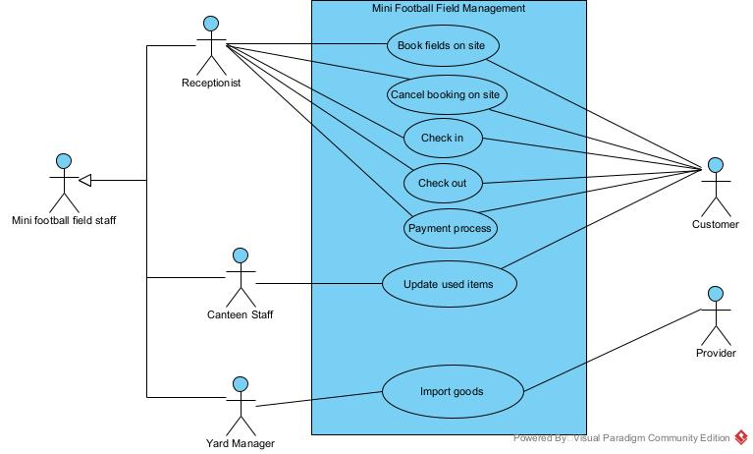
2. Describe Use Case
- Book fields on site: This Use Case enables the Receptionist to book fields on site with the requirement of the Customer.
- Cancel booking on site: This Use Case enables the Receptionist to cancel a booking on site with the requirement of the Customer.
- Check in: This Use Case enables the Receptionist to check in with the requirement of the Customer.
- Check out: This Use Case enables the Receptionist to check out with the requirement of the Customer.
- Process Payment: This Use Case enables the Receptionist to process the payment with the requirement of the Customer.
- Update used items: This Use Case enables the Canteen Staff to update the list of food product that the Customer has use with the requirement of the Customer.
- Import goods: This Use Case enables the Yard Manager to import goods with the requirement of the Provider.
3. Detail Use Case diagram for module 3: Customer paying

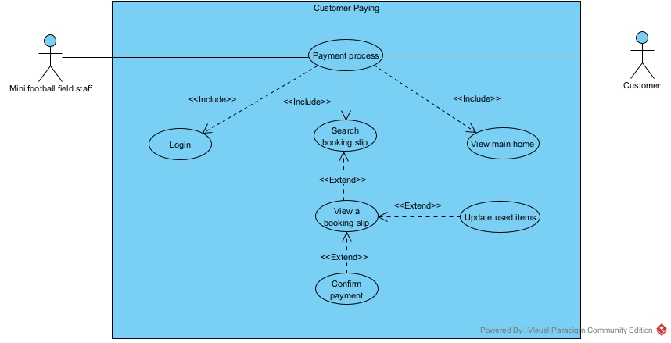
- Description:
- Login: This use case let the mini football field staff log in to the system
- View main home page: This use case let the mini football field staff choose the function that the staff can access
- Payment process: This use case let the mini football field staff use the payment process function
- Search booking slip: This use case let the mini football field staff search the booking slip by the current customer information
- View a booking slip: This use case let the staff view the correct booking slip with the provided customer’s information
- Update used items: This use case let the mini football field staff change or update the detailed list of the used items in case the customer complains
- Confirm payment: This use case let the mini football field staff confirm that the payment for the booking slip has been made

C. Analysis
1. Scenario
Scenario | Update Used Items of the rental session
Actor(s) | Receptionist, Customer
Pre-condition | Receptionist has a receptionist account
Post-condition | - The payment for the session is saved in the database  - The detailed list of the used items of the session is updated if the customer has a complain
Main-events | 1. The receptionist A open the app to process the payment for the rental session of the customer B  2. The system display a login interface with a field to enter username, a field to enter password and a Login button  3. The receptionist enter username = “a”, password = “staff@123” and click Login  4. The system display the main interface with the option to process payment  5. The receptionist click on the option to process payment  6. The system displays the search for customer with the input of customer name  7. The receptionist ask the customer about their name  8. The customer answer that their name is B  9. The receptionist enter the name B + click search  10. The system show the result interface  11. The receptionist ask the customer about their phone number  12. The customer answer with 9235692  13. The receptionist click on the select button of the correct customer  14. The interface shows a list of booking ticket with that customer name  15. The receptionist ask the customer which booking slip they want to make payment for  16. The customer answer the rental period between 01/04/2025 to 30/06/2025  17. The receptionist clicks the payment button next to the correct rental period  18. The system shows the interface  19. The customer confirm the information in the invoice, paid the money and the receptionist click the confirm button  20. The system display a confirm box, with a field to enter payment method, a confirm button and a cancel button  21. The receptionist enter the payment method and click confirm button  22. The system display a success alert, confirming that the payment have been successfully save into the database and then returns to the main interface
  Name : B |  |  |  |  | Search button
  N# | ID | Name | Phone | Email | Select
  1 | 2 | B | 9235692 | B@gmail.com | Select
  2 | 5 | B | 2945834 | NVB@gmail.com | Select
  Name : B
  N# | ID | Rental period | Select
  1 | 2 | 01/04/2025-30/06/2025 | Payment
  2 | 5 | 01/07/2025-30/09/2025 | Payment
  Invoice |  | Confirm
  Customer Information
  Name | Phone |  | Email
  B | 9235692 |  | B@gmail.com
  Items used
  N# | Name |  | Quantity
  Session 1: 01/04/2025
  1 | Pepsi |  | 10
  2 | Revive |  | 5
  Session 2: 30/06/2025
  1 | Revive |  | 5
  Subtotal |  |  | 200.000 VND
  Total |  |  | 21.600.000 VND
Exception | 4. The system display a “Login failed” alert and a Confirm button  4.1. The receptionist click the Confirm button  4.2. The system show the login interface  4.3. The receptionist enter the username and password correctly  4.4. The system display the main interface  19. The customer has a complain about this list of items used in the session  19.1. The receptionist click on an item that the customer complain about  19.2. The system show a pop-up interface with the name of the item, a field to enter that item quantity, and a Confirm button  19.3. The receptionist enter the number that item base on the customer’s complain and click Confirm  19.4. The system close the pop-up interface, and the invoice is update with the item’s new quantity  19.5. The receptionist then repeat step 19.1. to 19.4. for all the item that the customer complain about
  Item | Pepsi
  Quantity
  Cancel | Confirm
2. Entity class extraction
- Step 1: Describe the system in a paragraph or a scenario + exceptions
- Step 2+3: Extract and evaluate nouns in Step 1
+ Receptionist => Need to be managed => Class User: full name, username, password, role
+ Customer => Need to be managed => Class Customer: full name, phone, email, note
+ Account => Too generic => Eliminate
+ Session => Need to be managed => Class Session: receptionTime, returnTime, duration, status, note
+ Database => Too generic => Eliminate
+ Item => Need to be managed => Class Item: name, price, amount,
unit, category
+ Invoice => Need to be managed => Class Invoice: paymentDate,
isPaid, paymentMethod, totalAmount
+ System => Too generic => Eliminate
+ Interface => Too generic => Eliminate
+ Button => Too generic => Eliminate
+ Rental period => Too generic => Eliminate
+ Booking ticket => Need to be managed => Class BookingTicket: startDate, endDate, status, createDate, note
+ Alert => Too generic => Eliminate
+ Court => Need to be managed => Class Court: type, description, note, condition
=> Class extracted: User, Customer, Session, BookingTicket, Payment, Item
- Step 4: Consider quantities relationship among classes
+ 1 booking ticket has 1 customer, 1 customer can have 0 or many booking ticket => 1-n relationship
+ 1 booked court can has many session, 1 session belongs to 1 booked court => 1-n relationship
+ 1 session can have 0 or many items used, 1 item can be used in 0 or many session => n-n relationship => Create class UsedItem
+ 1 user can make 0 or many invoice, 1 invoice can be made by only 1 user => 1-n relationship
+ 1 booking ticket has 1 invoice, 1 invoice belongs to 1 booking ticket => 1-1 relationship
+ 1 booking ticket can be made by 1 user, 1 user can make many booking ticket => 1-n relationship
+ 1 booking ticket can book many courts, 1 court can be booked in many booking ticket => n-n relationship => Create class BookedCourt
+ 1 invoice can only have1 customer, 1 customer can have many invoice => 1-n relationship

- Step 5: Determine the object relationship among entity classes
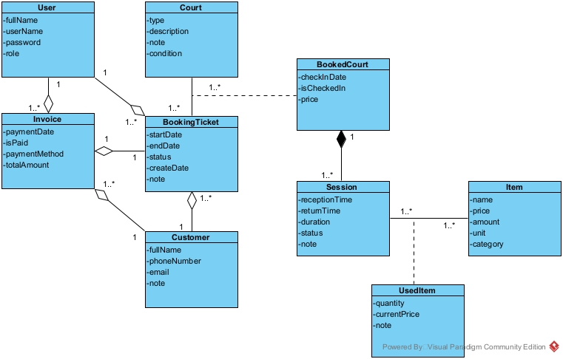
3. Full class diagram
- When the receptionist open the app, the system display a login interface => LoginView:
+ Input for username: inUsername
+ Input for password: inPassword
+ Login button: subLogin
- When click the login button, the system check username and password => a function:
+ Name: checkLogin()
+ Input: username, password
+ Output: boolean
+ Owner class: User
- The system displays the main interface => Class MainHomeView:
+ With at least an option Customer paying => subCustomerPaying
- Click on Customer Paying, the interface to search for customer by name appears => Class SearchCustomerView:
+ Input customer name: inName
+ Search button: subSearch
+ List of customer: outsubListCustomer
- Click on search button to search customer by name => a function:
+ Name: searchByName()
+ Input: Customer name
+ Output: List of customer
+ Owner class: Customer
- Click on a customer to show their booking ticket => a function:
+ Name: showBookingTicket()
+ Input: An object of customer
+ Output: List of booking ticket from a customer
+ Owner class: BookingTicket
- Click on a customer, the interface to show the list of booking ticket appears => Class CustomerBookingTicketView:
+ List of booking ticket: outsubListBookingTicket
- Click on the payment button of 1 booking ticket, the interface with the invoice with full customer information and detailed list of items used in the session appear => Class InvoiceView :
+ Confirm the payment: subConfirm
+ List of used item that can be changed: outsubListUsedItem
+ Invoice with full customer information: outInvoice
- Click on the payment button of 1 booking ticket, the invoice with full customer information is shown => a function:
+ Name: getInvoice()
+ Input: An object of booking ticket
+ Output: The invoice for that booking ticket
+Owner class: Invoice
- Click on 1 item, the interface to change item quantity appear => Class ChangeItemNumberView:
+ Input : inNumber
+ Confirm button: subConfirm
+ Cancel button: subCancel
- When click confirm to change item quantity, the system update the invoice in the system => a function:
+ Name: updateUsedQuantity()
+ Input: The number of an item
+ Output: Void
+ Owner class: UsedItem
- Click on confirm to update the payment => a function:
+ Name: setPayment()
+ Input: an object of booking ticket and payment method
+ Output: none or boolean
+ Owner Class: Invoice
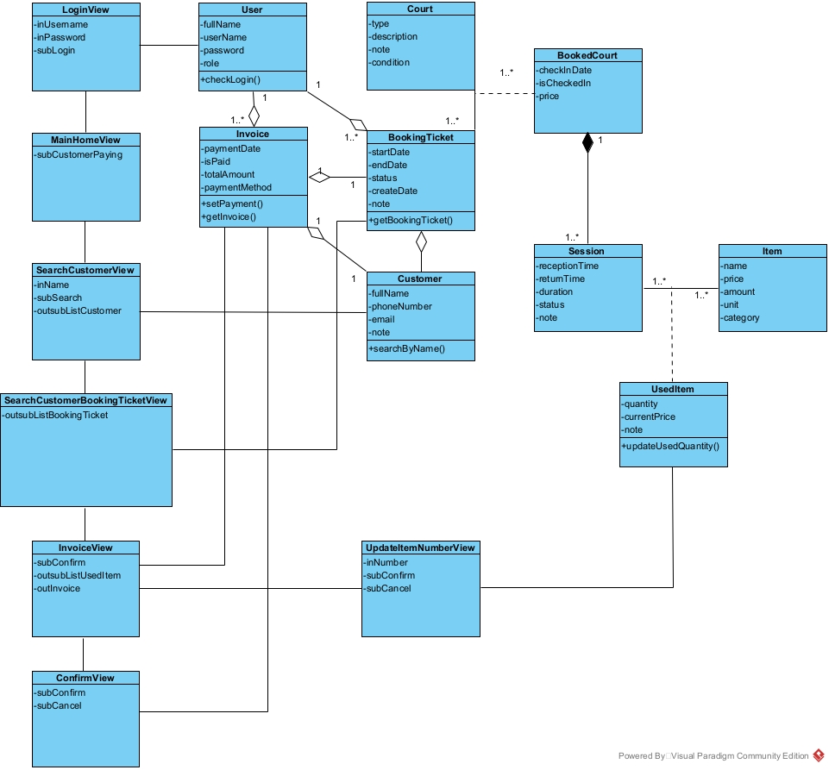
4. Scenario version 2
- Receptionist open the app, input username and password and click login in class LoginView
- Class LoginView calls class User
- Class User use checkLogin() to verify the log in. Log in success
- Class User return the result to class LoginView
- Class LoginView calls class MainHomeView
- Class MainHomeView displays itself to the receptionist
- The receptionist clicks subCustomerPaying button to use function “Customer paying”
- Class MainHomeView calls class SearchCustomerView
- Class SearchCustomerView displays itself to the receptionist
- The receptionist asks the customer for their name
- The customer says their name
- The receptionist enter the customer name and click search
- The class SearchCustomerView calls class Customer
- Class Customer use searchByName() to find the list of customer
- Class Customer return the result to the class SearchCustomerView
- Class SearchCustomerView displays the list of customer to the receptionist
- The receptionist asks the customer for their phone number
- The customer says their phone number
- The receptionist finds and clicks on the customer with the correct information
- The class SearchCustomerView calls the class CustomerBookingTicketView
- The CustomerBookingTicketView call the class BookingTicket
- The class BookingTicket use function getBookingTicket() to find the list of a customer booking tickets
- The class BookingTicket return the result to the CustomerBookingTicketView class
- The class CustomerBookingTicketView displays itself along with the list of booking tickets from a customer to the receptionist
- The receptionist ask the customer which booking ticket they want to make payment for
- The customer response with the period of the correct booking ticket
- The receptionist clicks on the correct booking tickets from the list
- The class CustomerBookingTicket calls the class InvoiceView
- The class InvoiceView calls the class Invoice
- The class Invoice use function getInvoice() to find the invoice
- The class Invoice return the result to the InvoiceView class
- The class InvoiceView display itself along with the invoice
- The receptionist then asks the customer to confirm the invoice and make payment
- The customer confirms and pays for the invoice
- The receptionist then clicks confirm
- The class InvoiceView calls class ConfirmView
- The class ConfirmView displays itself to the receptionist
- The receptionist enter payment method and clicks Confirm
- The class ConfirmView calls class Invoice
- The class Invoice use function setPayment()
- The class Invoice return to the class ConfirmView
- The class ConfirmView displays a success message to the receptionist
- The receptionist click “OK” in the message
- The class ConfirmView call class MainHomeView
- The class MainHomeView displays itself to the receptionist
- The receptionist informs the successful payment to the customer
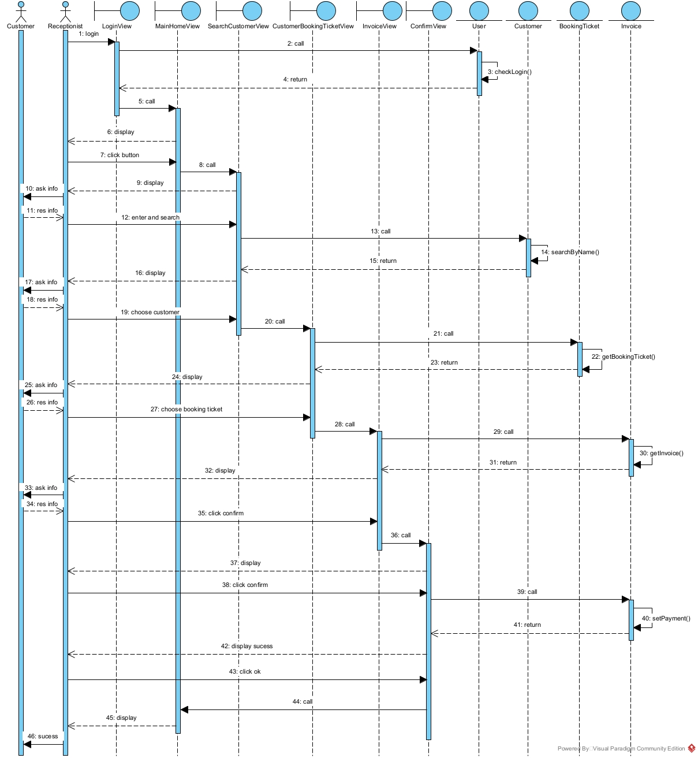

D. Design
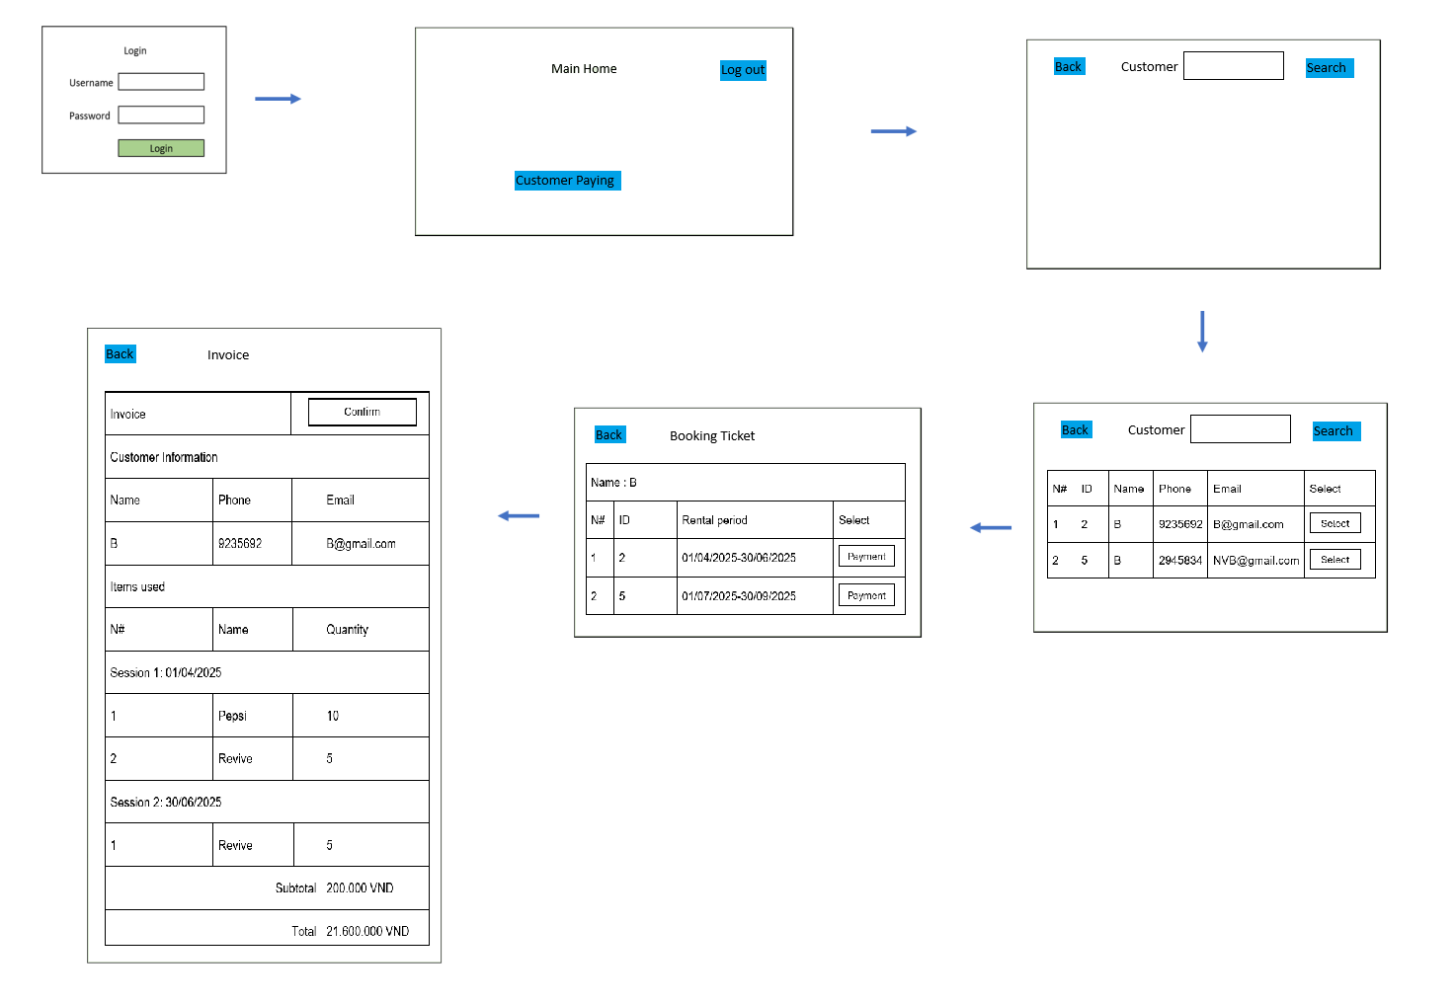
1. Entity class design
- Step 1: Add the id attribute for the classes which DO NOT inherit from other class Court, BookedCourt, BookingTicket, Customer, User, Session, UsedItem, Item, Invoice.

- Step 2: Add the type of each attribute in all classes:
- User:
  - fullName: String
  - username: String
  - password: String
  - note: String
- Invoice:
  - paymentDate: Date
  - isPaid: bit
  - paymentMethod: String
  - totalAmount: int
- BookedCourt:
  - checkinDate: Date
  - isCheckedIn: bit
  - price: int
- Court:
  - type: String
  - description: String
  - note: String
  - condition: String
- BookingTicket:
  - startDate: Date
  - endDate: Date
  - status: String
  - createdDate: Date
  - note: String
- Customer:
  - fullName: String
  - phoneNumber: String
  - email: String
  - note: String
- Session:
  - receptionTime: String
  - returnTime: String
  - duration: String
  - status: String
  - note: String
- Item:
  - name: String
  - price: int
  - amount: int
  - unit: String
  - category: String
- UsedItem:
  - quantity: int
  - currentPrice: int
  - note: String

- Step 3: Convert all association relationships to correspond aggregation/ composition relationships:
BookingTicket + Court-> BookedCourt is converted to: Court is a component of BookedCourt, BookedCourt is a component of BookingTicket.
Session + Item-> UsedItem is converted to: Item is a component of UsedItem, UsedItem is a component of Session.

- Step 4: Add the object attributes which correspond to the aggregation/composition relationships:
- Court is a component of BookedCourt, of type 1-n -> BookedCourt has a Court
- BookedCourt is a component of BookingTicket, of type n-1 -> BookingTicket has a BookedCourt
- Customer is a component of BookingTicket, of type 1-n -> BookingTicket has a Customer
- Customer is a component of Invoice, of type 1-n -> Invoice has a Customer
- User is a component of BookingTicket, of type 1-n -> BookingTicket has an User
- User is a component of Invoice, of type 1-n -> Invoice has an User
- BookingTicket is a component of Invoice, of type 1-1 -> Invoice has an BookingTicket
- Item is a component of UsedItem, of type 1-n -> UsedItem has a Item
- UsedItem is a component of Session, of type n-1 -> Session has a list of UsedItem
- Session is a component of BookingTicket, of type n-1 -> BookingTicket has a list of Session
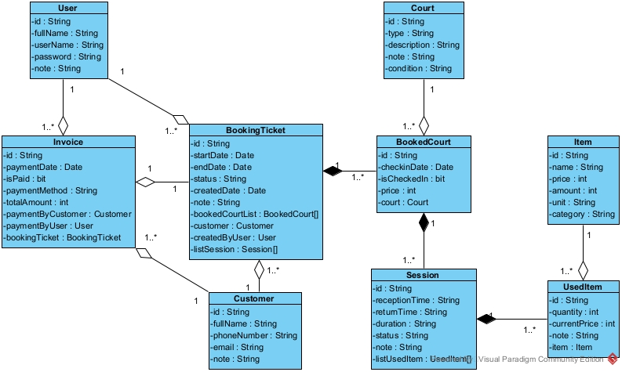
2. Database design
Input is the entity class diagram from the design phase
- Step 1: For each entity class, create a corresponding table.
User -> tblUser
BookedCourt -> tblBookedCourt
Court -> tblCourt
Invoice -> tblInvoice
BookingTicket -> tblBookingTicket
Session -> tblSession
Item -> tblItem
Customer -> tblCustomer
UsedItem -> tblUsedItem

- Step 2: For each entity class, transfer all non-object attributes to contribute as the columns of the corresponding table.
- tblUser:
  - id: varchar(50)
  - fullName: varchar(50)
  - userName: varchar(50)
  - password: varchar(50)
  - note: varchar(50)
- tblBookedCourt:
  - id: varchar(50)
  - checkinDate: date
  - isCheckedIn: bit
  - price: int
- tblCourt:
  - id: varchar(50)
  - type: varchar(50)
  - description: varchar(50)
  - note: varchar(50)
  - condition: varchar(50)
- tblInvoice:
  - id: varchar(50)
  - paymentDate: date
  - isPaid: bit
  - paymentMethod: varchar(50)
  - totalAmount: int
- tblBookingTicket:
  - id: varchar(50)
  - startDate: date
  - endDate: date
  - status: varchar(50)
  - createdDate: date
  - note: varchar(50)
- tblSession:
  - id: varchar(50)
  - receptionTime: varchar(50)
  - returnTime: varchar(50)
  - duration: varchar(50)
  - status: varchar(50)
  - note: varchar(50)
- tblItem:
  - id: varchar(50)
  - name: varchar(50)
  - price: int
  - amount: int
  - unit: varchar(50)
  - category: varchar(50)
- tblCustomer:
  - id: varchar(50)
  - fullName: varchar(50)
  - phoneNumber: varchar(50)
  - email: varchar(50)
  - note: varchar(50)
- tblUsedItem:
  - id: varchar(50)
  - quantity: int
  - currentPrice: int
  - note: varchar(50)

- Step 3: Consider the quantity relationships among entity classes. These relationships will be those among corresponding tables:
1 User – n BookingTicket
1 User – n Invoice
1 Customer – n BookingTicket
1 Customer – n Invoice
1 Invoice – 1 BookingTicket
1 Court – n BookedCourt
1 BookingTicket – n BookedCourt
1 BookingTicket – n Session
1 Session – n UsedItem
1 Item – n UsedItem

- Step 4: Configure the key column for tables.
- tblUser:
  - id: primary key
- tblBookedCourt:
  - id: primary key
  - The relationship between tblCourt and tblBookedCourt is 1-n -> tblBookedCourt will save the foreign key of CourtID references to tblCourt.
  - The relationship between tblBookingTicket and tblBookedCourt is 1-n -> tblBookedCourt will save the foreign key of BookingTicketID references to tblBookingTicket.
- tblCourt:
  - id: primary key
- tblInvoice:
  - id: primary key
  - The relationship between tblUser and tblInvoices is 1-n -> tblInvoices will save the foreign key of UserID references to tblUser.
  - The relationship between tblCustomer and tblInvoices is 1-n -> tblInvoices will save the foreign key of CustomerID references to tblCustomer.
  - The relationship between tblBookingTicket and tblInvoices is 1-1 -> tblInvoices will save the foreign key of BookingTicketID references to tblBookingTicket.
- tblBookingTicket:
  - id: primary key
  - The relationship between tblUser and tblBookingTicket is 1-n -> tblBookingTicket will save the foreign key of UserID references to tblUser.
  - The relationship between tblCustomer and tblBookingTicket is 1-n -> tblBookingTicket will save the foreign key of CustomerID references to tblCustomer.
- tblSession:
  - id: primary key
  - The relationship between tblBookingTicket and tblSession is 1-n -> tblSession will save the foreign key of BookingTicketID references to tblBookingTicket.
- tblItem:
  - id: primary key
- tblCustomer:
  - id: primary key
- tblUsedItem:
  - id: primary key
  - The relationship between tblItem and tblUsedItem is 1-n -> tblUsedItem will save the foreign key of ItemID references to tblItem.
  - The relationship between tblSession and tblUedItem is 1-n -> tblUsedItem will save the foreign key of ItemID references to tblItem.

- Step 5: Delete the derived attribute and abundant attribute
Derive Attribute: totalAmount in tblInvoices.
The database for the system:
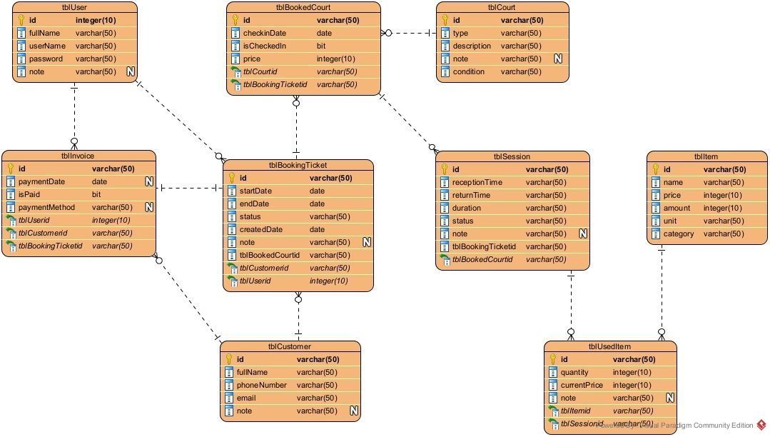
3. Static design
In this module, the login processing is omitted.
View class
- LoginFrm is the interface to log in. It needs a text field to enter the username, a text field to enter a password, and a button to log in.
- MainHomeFrm is the home interface of the employee. It needs at least a button to go to the receptionist payment function and a button to logout.
- SearchCustomerFrm is the interface of searching customer. It includes a search button function, a text field to enter customer name and a table displaying list of all customer.
- SearchBookingTicketFrm is the interface of searching booking ticket. It includes a table displaying all booking ticket of a customer.
- InvoiceFrm is the interface of displaying invoice. It includes a button to confirm the payment and a table displaying the list of used item.
- ConfirmFrm is the interface of confirm payment. It includes a text field to enter the payment method, a button to confirm and a button to cancel.
- UpdateItemNumberFrm is the interface of updating item number. It needs the input text field to enter the number of the item, a button to confirm the update and a cancel button.
Control(DAO) class:
- DAO is a general class of DAO. It has only the construction to connect to the DB and provides the common connection for all inherited DAO classes in the system.
- UserDAO is the class for manipulating with DB related to the User object. In this module, it needs a method:
  - checkLogin(): to verify whether the login information is correct or not.
    - Input: User, ensure encapsulation
    - Output: Boolean, check if the login is valid, if not return false
- CustomerDAO is the class for manipulating with DB related to the Customer object. In this module, it’s need a method:
  - searchByName(): to search all customer whose name contains the keyword.
    - Input: String, the information is given by the customer for the receptionist to enter
    - Output: Customer[], there can be many customer with the same name
- BookingTicketDAO: is the class for manipulating with DB related to the booking ticket object. In this module, it’s need a method:
  - getBookingTicket(): to search all booking tickets which belong to a customer.
    - Input: Customer, ensure encapsulation
    - Output: BookingTicket[], one customer can have many booking tickets
- InvoiceDAO: is the class for manipulating with DB related to the Invoices Object. In this module, it’s need 2 method:
  - getInvoice(): to retrieve all information of the invoice
    - Input: BookingTicket, ensure encapsulation
    - Output: Invoice, ensure encapsulation
  - setPayment(): to set invoice payment method and confirm payment.
    - Input: Invoice, ensure encapsulation
    - Output: Boolean, return true if the payment has been updated successfully
- UsedItemDAO: is the class for manipulating with DB related to the used item Object. In this module, it’s need a method:
  - updateUsedQuantity(): to update the quantity of an item in the invoice
    - Input: UsedItem, ensure data encapsulation
    - Output: void, the number of item only need to be updated
Entity classes: User, Invoices, BookingTicket, Session, Customer, Item, UsedItem
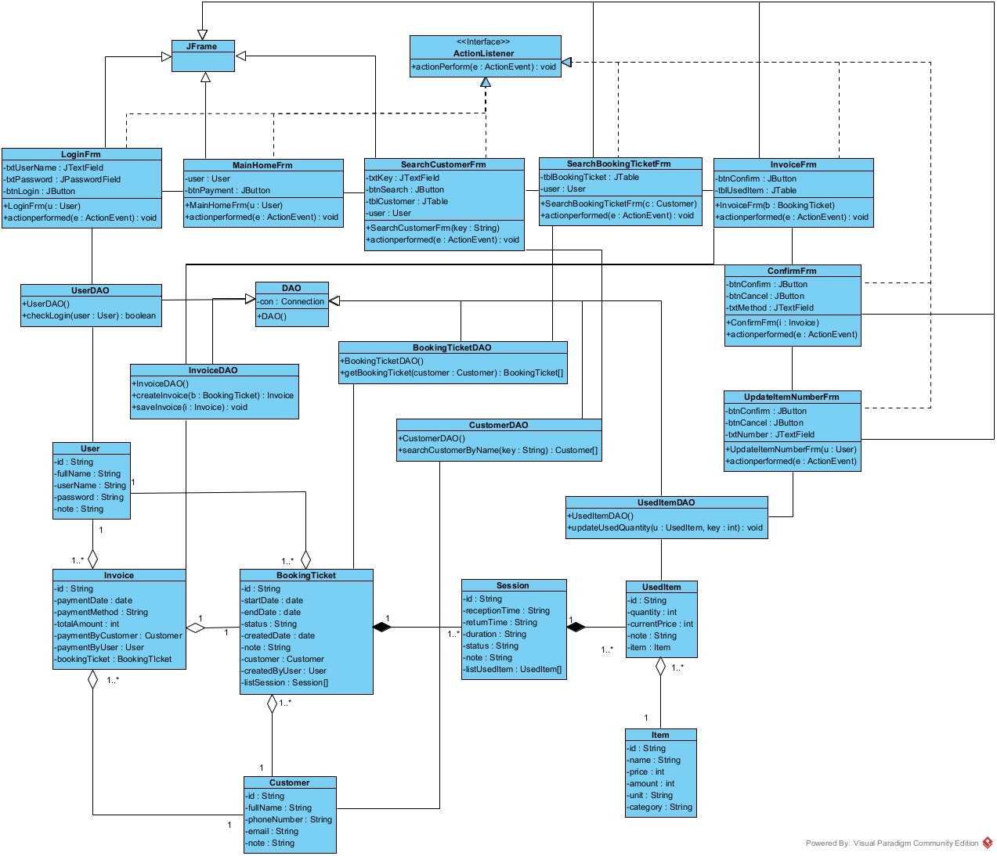
4. Dynamic design
- A customer come to make payment
- The receptionist enter username, password and click login button on LoginFrm
- The method actionperformed() of LoginFrm() is called
- The method actionperformed() calls User to create an User object
- The class User packs the information into an User object
- The class User returns User object to the method actionperformed().
- The method actionperformed() calls method checkLogin() of the class UserDAO
- The method checkLogin() checks the login information
- The method checkLogin() calls the class User set more two attributes name, role
- The class User calls its method setName(), setRole()
- The class User returns the User object to the method checkLogin()
- The method checkLogin() returns the results to the actionPerformed()
- The method actionPerformed() calls the class MainHomeFrm
- The constructor MainHomeFrm() is called
- The interface MainHomeFrm is shown to the receptionist
- The receptionist clicks on the customer paying button
- The method actionperformed() of the class MainHomeFrm is called
- The method actionPerformed() calls the class SearchCustomerFrm
- The constructor SearchCustomerFrm() is called
- The interface SearchCustomerFrm is shown to the receptionist
- The receptionist asks the customer about their name
- The customer responds with their name
- The receptionist enter their name into the name field and click search
- The method actionperformed() is called
- The method actionPerformed() calls the method searchByName() of the class CustomerDAO
- The method searchByName() is executed
- The method searchByName() calls the class Customer to pack the results
- The class Customer pack each result into a Customer object
- The class Customer returns the object to the method searchByName()
- The method searchByName() returns the results to the method actionperformed()
- The method actionperformed() displays the results on the interface SearchCustomerFrm to the receptionist
- The receptionist asks for the customer phone number
- The customer responds with their phone number
- The receptionist clicks on the correct customer
- The method actionperformed() of the class SearchCustomerFrm is called
- The method actionperformed() calls the class actionperformed() of the class SearchBookingTicketFrm
- The method actionperformed() of the class SearchBookingTicketFrm is called
- The method actionperformed() calls the method getBookingTicket() of the class BookingTicketDAO
- The method getBookingTicket() of the class BookingTicketDAO is executed
- The method getBookingTicket() calls the class BookingTicket() to pack the results
- The class BookingTicket pack each result into a BookingTicket object
- The class BookingTicket returns the object to the method getBookingTicket()
- The method getBookingTicket() returns the results to the method actionperformed()
- The constructor MainHomeFrm() is called
- The method actionperformed() displays the results on the interface SearchBookingTicketFrm to the receptionist
- The receptionist then asks the customer which booking ticket they want to make payment for
- The customer responds with the booking ticket they want to make payment for
- The receptionist click the correct booking ticket
- The method actionperformed() of the class InvoiceFrm is called
- The method actionperformed() called the method actionperformed() of the class InvoiceFrm
- The method actionperformed() of the class InvoiceFrm is called
- The method actionperformed() calls the method getInvoice() of the class InvoiceDAO
- The method getInvoice() is executed
- The method getInvoice() calls the class Invoice to pack the result
- The class Invoice pack the result into an Invoice object
- The class Invoice returns the object to the method getInvoice()
- The method getInvoice() returns the results to the method actionPerformed()
- The contructor InvoiceFrm() is called
- The method actionperformed() displays the results on the interface InvoiceFrm to the receptionist
- The receptionist asks the customer for the confirmation and payment method
- The customer confirms and responds with the payment method
- The receptionist clicks confirm
- The method actionperformed() of the class InvoiceFrm is called
- The method actionperformed() calls the class ConfirmFrm
- The constructor ConfirmFrm() is called
- The interface ConfirmFrm is shown to the receptionist
- The receptionist enter the payment method and clicks confirm
- The method actionperformed() of the class ConfirmFrm is called
- The method actionperformed() calls the method setPayment() of the class InvoiceDAO
- The method setPayment() is executed
- The method setPayment() return the result to the class ConfirmFrm
- The class ConfirmFrm display a success message to the receptionist
- The receptionist clicks OK button
- The method actionPerformed() calls the interface MainHomeFrm
- The interface MainHomeFrm is shown to the Customer
- The receptionist confirms the successful payment to the customer

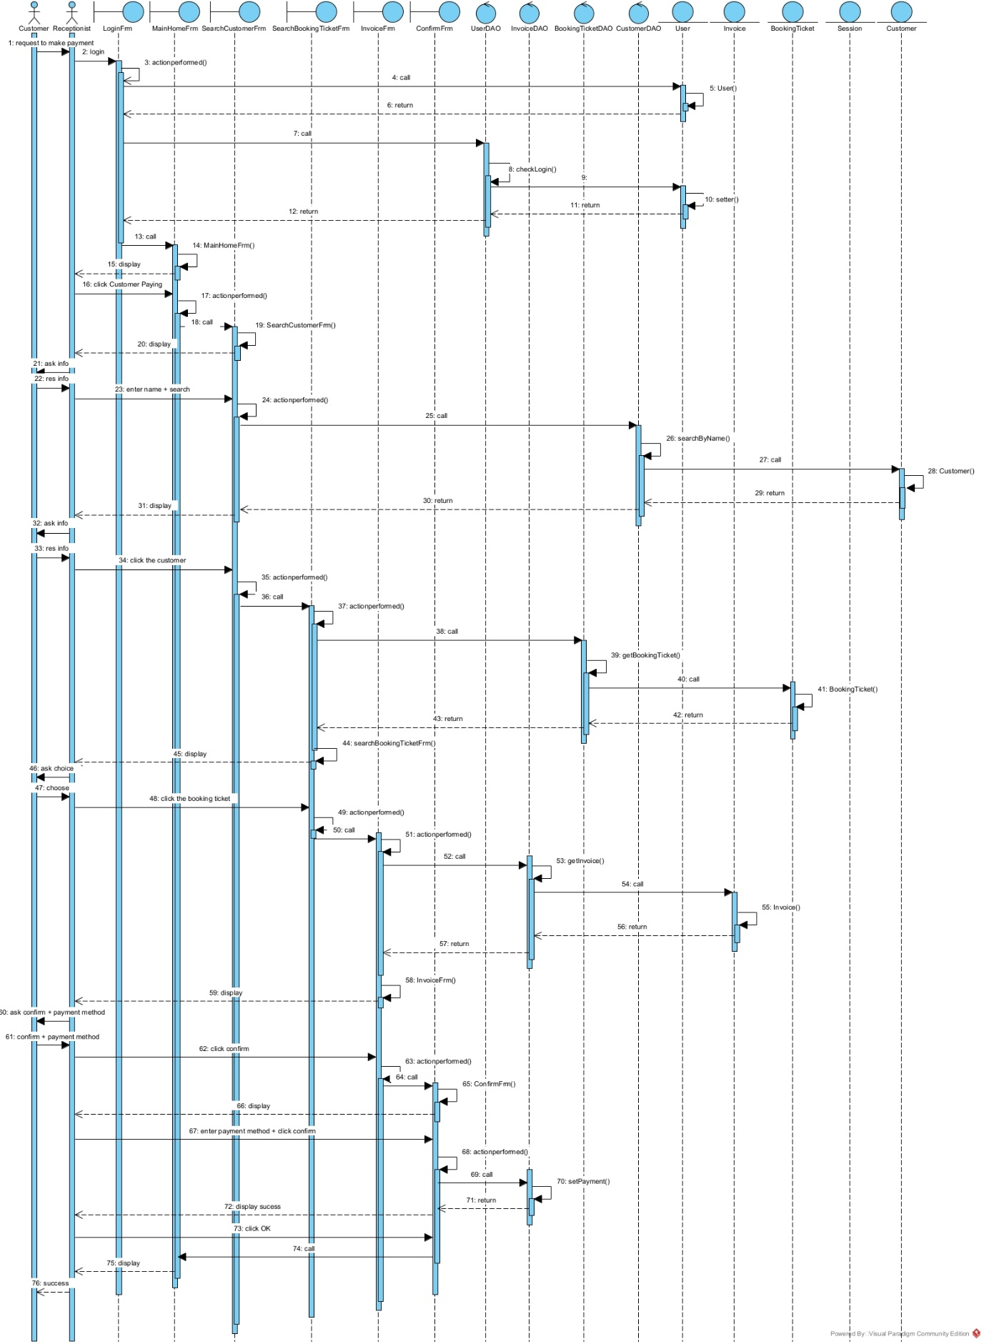
41 thieu dong goi -> dong goi session trc
53-56 phai to invoice truoc -> tao ham goi invoice
76 sai

E. Testing
1. Black-box test case list
No. | Module | Test case
1 | Customer paying | Customer exists, booking ticket exists
2 | Customer paying | Customer exists, booking ticket does not exist
3 | Customer paying | Customer does not exist, booking ticket exists
4 | Customer paying | Customer does not exist, booking ticket does not exist
5 | Customer paying | Make payment 2 consecutive times for 1 booking ticket
2. Test case No. 1
The database before testing:
tblUser:
id | username | password | name | role

tblCustomer:
id | name | address | phone | email | note

tblBookingTicket:
id | dateOfContract | depositAmount | CustomerId | UserId

tblCourt:
id | type | price | description

tblBookedCourt:
id | price | startDate | endDate | startHour | dayOfWeek | CourtId | BookingTicket

tblRentalSession:
id | receptionTime | returnTime | date | UserId | BookedCourtId

tblItem:
id | name | price | amount

tblUsedItem:
id | quantity | currentPrice | RentalSessionId | ItemId

tblInvoice:
id | paymentDate | isPaid | paymentMethod | UserId | CustomerId | BookingTicketId

